Do Fairness Benchmarks Agree? A Cross-Metric Analysis Framework for ML and LLM Bias Auditing
Final Project Writeup
Project Category | Benchmarking / Evaluation
Student Name(s) | Abdul Azeem Opakunle
Student Email(s) | [insert your course email before submission]
Course | DTSC 5505
Milestone | Milestone 6 – Final Report & Presentation
Submission Date | April 2026

Abstract
This report presents FairEval, a reproducible benchmarking framework for studying whether commonly used fairness metrics tell consistent stories about model behavior across multiple datasets and modalities. The project is positioned in the Benchmarking / Evaluation category and addresses a practical research problem that now has direct policy relevance: organizations are increasingly expected to document whether deployed models are fair, yet fairness is not a single measurable quantity. Instead, different metrics emphasize different error tradeoffs, different normative assumptions, and different operational definitions of harm. A model that appears acceptable under one fairness criterion may appear problematic under another. The core goal of FairEval is therefore not merely to compute a long list of scores, but to examine inter-metric agreement, surface disagreement explicitly, and package the full workflow in a form that is reproducible, inspectable, and presentation-ready.
The implemented system evaluates two classical supervised learning models—logistic regression and random forest—on three benchmark tabular datasets widely used in fairness research: Adult, COMPAS, and German Credit. For each model-dataset configuration, the system computes predictive accuracy, demographic parity difference, equalized odds difference, and predictive parity difference. In addition, it computes a Kendall’s tau agreement matrix and Krippendorff’s alpha to quantify whether the fairness metrics rank models consistently. The delivered artifact also includes optional adapters for light-weight LLM evaluation using CrowS-Pairs and BBQ, plus scripts for regenerating tables and figures. Empirically, the final results show high predictive performance on Adult and COMPAS and moderate performance on German Credit, but more importantly they reveal substantive disagreement among fairness metrics. Demographic parity and equalized odds move together in this implementation, while predictive parity frequently points in the opposite direction, yielding a negative overall Krippendorff’s alpha (-0.111111). This finding supports the central claim of the project: fairness auditing should be treated as a multi-metric diagnostic process rather than a single-score checkbox.

1. Introduction
Machine learning systems are now used in admissions, employment screening, credit decisions, policing, healthcare prioritization, content moderation, and many other settings where mistakes do not affect everyone equally. The modern fairness literature emerged from the recognition that statistical performance alone is not enough to assess whether such systems are acceptable. A classifier can be accurate on average while still imposing systematically different false positive rates, false negative rates, or opportunity structures across demographic groups. Large language models further complicate the situation because their harms may appear through stereotype reproduction, toxic associations, inequitable answer quality, or disparate treatment in prompt-conditioned outputs rather than through a single binary prediction.
At the same time, regulatory attention has intensified. Public-sector accountability rules, employment-law auditing requirements, and risk-based AI governance frameworks all increasingly demand evidence that high-impact systems have been evaluated for bias. The practical challenge is that “fairness” has no universally accepted scalar definition. The research community has proposed multiple formal criteria, including demographic parity, equal opportunity, equalized odds, calibration, predictive parity, counterfactual fairness, and individual fairness, among others. These criteria are not interchangeable. In fact, several are mutually incompatible except under restrictive conditions, particularly when base rates differ across groups. This creates a serious gap between policy expectations and technical reality: an organization asked to “measure fairness” may comply by reporting one convenient metric while ignoring another metric that points to a different conclusion.
The FairEval project is motivated by that gap. Rather than proposing yet another fairness metric, the project builds a benchmarking framework whose primary intellectual contribution is diagnostic transparency. The framework standardizes data loading, preprocessing, model training, fairness computation, agreement analysis, output persistence, and figure generation. In other words, it operationalizes a workflow that allows the evaluator to say not only “here are the metric values” but also “here is whether the metrics themselves agree on the relative fairness of the tested models.” This framing responds directly to a common failure mode in fairness practice: presenting a single favorable number as if it settles an inherently plural and context-dependent problem.
A second motivation is cross-modal extensibility. Many existing fairness toolkits are strong either for classical tabular machine learning or for modern language-model evaluation, but not both. The project roadmap therefore set out to support both tabular datasets and language-model benchmarks in a single framework. The final delivered implementation fully operationalizes the tabular analysis pipeline and packages optional LLM evaluation adapters together with benchmark data for CrowS-Pairs and BBQ. Although the strongest empirical results in this report come from the tabular pipeline, the implementation was intentionally structured to preserve the roadmap’s broader cross-modal direction. This matters because the same core question—whether evaluators reach the same fairness conclusion under different metrics—exists in both predictive and generative contexts.
This final report therefore has four intertwined objectives. First, it documents the conceptual foundations for multi-metric fairness evaluation and situates FairEval in the existing literature. Second, it describes the final system design, datasets, models, metrics, agreement analysis procedures, and reproducibility strategy. Third, it reports empirical findings from three tabular benchmark datasets and interprets the results in terms of inter-metric disagreement, dataset-specific difficulty, and practical audit implications. Fourth, it critically reflects on the remaining limitations of the implementation, especially the incomplete realization of some ambitious roadmap items, and identifies the next steps required to turn the framework from a strong course artifact into a more fully developed research and engineering contribution.
The report is organized as follows. Section 2 surveys related work across fairness toolkits, benchmark suites, and theoretical debates about fairness definitions. Section 3 presents the methodology and system design, including the supported metrics and agreement statistics. Section 4 documents the datasets, preprocessing, and experimental setup. Section 5 describes implementation details and packaging decisions for reproducibility. Section 6 presents the main quantitative results and figures. Section 7 interprets those results, discusses what they mean for the roadmap’s central hypothesis, and explains how the final package addresses the Milestone 6 requirements. Section 8 outlines the main limitations and threats to validity. Section 9 concludes with future work.

2. Related Work
The FairEval framework sits at the intersection of three strands of research: formal fairness in supervised learning, practical fairness tooling and benchmarking, and emerging work on bias evaluation for large language models. Each strand informs the design of the final system.
The first strand concerns formal definitions of fairness and the impossibility of collapsing them into a universal scalar notion. Hardt, Price, and Srebro’s work on equality of opportunity popularized the view that fairness can be defined in terms of equal error behavior across groups, especially by aligning true positive rates. Chouldechova and Kleinberg et al. subsequently showed that several intuitively appealing criteria—such as calibration, balance for positive and negative classes, and equalized odds—cannot in general all be satisfied simultaneously when base rates differ. This impossibility result is central to FairEval. It implies that a benchmarking framework should not simply output a single “fair/unfair” decision. Instead, it should make the evaluator confront the fact that different criteria capture different normative commitments. Demographic parity prioritizes parity in positive outcomes; equalized odds focuses on parity in error rates; predictive parity focuses on the reliability of positive predictions. If these metrics diverge, that divergence is itself an important empirical result.
The second strand concerns software tooling. IBM’s AI Fairness 360 (AIF360) is one of the most influential open-source toolkits for fairness in tabular machine learning. It provides a large library of metrics and mitigation algorithms, especially for binary classification settings. Microsoft’s Fairlearn takes a closely related but somewhat lighter-weight approach, with a strong emphasis on disaggregated evaluation and fairness-aware model selection for scikit-learn compatible workflows. Aequitas, the What-If Tool, and related responsible-AI suites contribute strong reporting and interactive analysis capabilities. These frameworks are important predecessors because they establish what a practical fairness toolkit should do: ingest data, align group labels, compute metrics, and present findings in a form that decision-makers can inspect.
However, the existing tool ecosystem also reveals a gap. Most mature fairness toolkits are still strongest on classical tabular or structured prediction problems. They were not originally designed to benchmark generative large language models on datasets such as CrowS-Pairs, BBQ, StereoSet, BOLD, or WinoBias. Conversely, LLM-focused benchmark suites such as HELM, DecodingTrust, and newer domain-specific libraries often include fairness as only one dimension among many, or else they focus narrowly on textual bias without integrating classical model evaluation. FairEval’s roadmap therefore proposed a unifying perspective: use one framework to organize tabular classification fairness metrics and language-model bias probes, then compare not only models but also the relationships among metrics. That unifying perspective is still a meaningful design contribution even where the final implementation is stronger on the tabular side than the LLM side.
A third strand of literature is directly about bias evaluation in language technologies. CrowS-Pairs introduced a sentence-pair benchmark for measuring stereotypical preferences in masked language models and helped crystallize how benchmark design can encode assumptions about what counts as biased language. BBQ extended the conversation by providing context-sensitive multiple-choice question answering examples that probe social bias across multiple demographic categories and question polarities. Later work has shown that many bias benchmarks are themselves imperfect proxies. Annotation quality, benchmark templating, language coverage, and ambiguity in normative labeling all affect what a score really means. FairEval incorporates these insights in two ways. First, it treats benchmark outputs as evidence rather than ground truth. Second, it positions agreement analysis as a partial corrective: when metrics disagree strongly, the evaluator is warned not to overclaim.
The project’s own planning documents also highlighted a further novelty direction: an LLM-as-a-Fairness-Judge component. The conceptual idea is that some harmful outputs may be easier to assess through structured judgment prompts than through a single automatically computed metric. This idea parallels broader LLM-as-a-judge work in evaluation research, where models are used to rate helpfulness, reasoning quality, or alignment under carefully structured prompts. In the fairness context, such an approach could potentially act as an additional rater whose decisions can be compared with human annotations and with automated metrics. The final delivered package includes the scaffolding for lightweight LLM benchmark execution but does not yet implement a validated LLM-as-a-Fairness-Judge module. That gap is therefore discussed as future work rather than claimed as a completed contribution.
The present implementation also draws on the literature on reproducible computational research. One lesson from that literature is that evaluation claims are only persuasive when the computational path from raw data to final figure is documented and repeatable. FairEval therefore emphasizes script-driven execution, explicit output directories, stored CSV artifacts, pinned dependency files, and packaging decisions that help another user rerun or inspect the work. This orientation matters for a fairness project in particular because auditability is not just a convenience feature; it is part of the substantive argument. If a fairness claim cannot be reproduced, inspected, or challenged, it loses much of its value in practice.
Relative to the literature, the final FairEval implementation should therefore be understood as a benchmark-centric synthesis project with a clear empirical thesis. It does not claim to supersede AIF360, Fairlearn, HELM, or DecodingTrust on raw coverage. Instead, it aims to make one focused contribution: surface inter-metric agreement and disagreement in a reproducible way while providing a pathway toward cross-modal extension. That focus is also consistent with the instructor feedback, which emphasized that the project would be strongest if it moved beyond “wrapper of wrappers” integration work and articulated a concrete empirical question. The question adopted here is direct: when multiple fairness metrics are applied to the same models and datasets, do they rank model behavior consistently enough to support simple fairness conclusions? The remainder of the report answers that question using the implemented artifact.
Beyond toolkit comparisons, the related-work landscape also includes debates about normative framing. Some scholars argue that group fairness metrics are useful because they expose systematic disparities and produce operationally checkable constraints. Others warn that purely statistical fairness can obscure structural harms, entrench problematic categories, or incentivize “fairness washing,” where organizations optimize to the metric rather than to the underlying social goal. FairEval acknowledges these critiques and adopts a limited but defensible position. Benchmarking metrics is worthwhile because institutions are already using them; better to expose disagreement and ambiguity than to pretend it does not exist. At the same time, the framework deliberately does not equate metric agreement with ethical adequacy. Agreement is a diagnostic property of the evaluation process, not a guarantee that a system is normatively acceptable.
Finally, the project is informed by comparative work on model transparency and error analysis. Accuracy alone is often highest on the dataset with the strongest signal or most regular label structure, yet those are not necessarily the datasets where fairness behavior is most stable. Fairness benchmarking therefore requires looking at predictive performance, group-conditioned behavior, and metric relationships together. This multi-perspective orientation strongly shapes the structure of the final report: results are presented not as a leaderboard but as an interconnected set of tables, plots, and interpretations that illuminate when metrics reinforce each other and when they conflict.

3. Methodology / System Design
FairEval is designed as a modular benchmarking pipeline. The system separates data loading, preprocessing, model construction, experiment execution, fairness metric computation, agreement analysis, optional LLM evaluation, and figure generation into distinct components. This section explains both the conceptual workflow and the formulas implemented by the final artifact.
At a high level, the pipeline follows six stages. Stage 1 loads dataset-specific CSV files and normalizes them into pandas DataFrames. Stage 2 applies dataset-specific preprocessing to identify labels, derive or normalize sensitive attributes, split the data into train and test partitions, and transform features using a scikit-learn preprocessing pipeline. Stage 3 trains baseline models on the transformed features. Stage 4 computes predictive and fairness metrics on the held-out test split. Stage 5 aggregates the resulting scores into tables and computes agreement statistics across fairness metrics. Stage 6 produces figures for reporting and presentation. This sequence is intentionally simple, auditable, and scriptable, making it suitable for both course grading and future extension.
The tabular evaluation path is implemented in the following source modules. The data_loader module reads the Adult, COMPAS, German Credit, CrowS-Pairs, and optional BBQ CSV files from the datasets directory. The preprocessing module contains dataset-specific functions that identify labels and sensitive attributes and then delegate to a shared split-and-transform routine. The models module exposes two scikit-learn classifiers: logistic regression and random forest. The experiments module orchestrates model training and evaluation across the supported tabular datasets. The fairness_metrics module computes the group disparity measures. The agreement module computes Kendall’s tau and Krippendorff’s alpha. The figures module and generate_figures.py script translate tabular outputs into presentation-ready PNG figures. The llm_eval and bbq_eval modules define optional API-based execution paths for CrowS-Pairs and BBQ when an OpenAI API key is available.
Three primary group fairness metrics are used in the final experiments. The first is demographic parity difference. In binary prediction settings, demographic parity asks whether the positive prediction rate is equal across groups. Let A denote the sensitive attribute and Ŷ the predicted label. A simple difference version can be written as
DP = | P(Ŷ = 1 | A = a) - P(Ŷ = 1 | A = b) |.
In this project, the score is computed as an absolute disparity between groups, so lower values are better. Demographic parity is attractive because it directly captures whether one group receives more positive outcomes than another, but it can also be controversial because it does not condition on the true label. A model can satisfy demographic parity while still making very different kinds of mistakes across groups.
The second metric is equalized odds difference. Equalized odds requires parity in both true positive rates and false positive rates across groups. Conceptually, if TPR_g and FPR_g denote the true positive and false positive rates for group g, one common two-group summary is
EO = 0.5 * ( |TPR_a - TPR_b| + |FPR_a - FPR_b| ).
Again, lower values indicate less disparity. Equalized odds is often seen as more sensitive to error allocation than demographic parity, particularly in high-stakes settings where false positives and false negatives have asymmetric harms.
The third fairness metric is predictive parity difference. Predictive parity focuses on the positive predictive value, or the share of positive predictions that are correct within each group. In a two-group setting, the difference form is
PP = | PPV_a - PPV_b |.
Predictive parity is especially relevant when the practical question is whether a positive model decision has equal meaning across groups. Yet it can conflict sharply with error-rate-based metrics when prevalence differs. That tension is one reason predictive parity is included in this study.
Although the report foregrounds fairness disparities, predictive accuracy is also retained as a reference performance metric because fairness results are easier to interpret when the underlying predictive quality is known. Accuracy is computed in the standard way as the proportion of correctly classified test instances. In practice, the project does not optimize a formal fairness-accuracy Pareto frontier, but the joint presentation of accuracy and fairness results makes that tradeoff visible.
A central methodological choice is the use of agreement statistics. Metric values alone can suggest whether a particular model-dataset configuration exhibits more or less disparity on a given criterion. They do not directly answer whether different fairness metrics rank models similarly. FairEval addresses this using two agreement measures. The first is Kendall’s tau, a rank-based correlation coefficient. For any pair of metrics, the implementation averages each metric across datasets at the model level, derives rankings of the tested models, and then computes tau between the rankings. A tau close to 1 indicates that the two metrics order the models similarly; a tau close to -1 indicates systematic disagreement. The second agreement statistic is Krippendorff’s alpha, which is computed by treating the metrics as “raters” of the models under an ordinal ranking scheme. Alpha summarizes whether the collection of metrics exhibits consensus beyond chance. Negative values indicate disagreement strong enough that the metrics are less aligned than one would expect from random variability.
Methodologically, this agreement analysis is the project’s core empirical mechanism. The central hypothesis is not that one model is universally fairer than another across all possible normative frameworks. Instead, the hypothesis is that fairness metrics may fail to agree strongly enough to support simplistic fairness conclusions. By operationalizing agreement quantitatively, FairEval turns that conceptual claim into a testable observation. If tau values are mixed and alpha is weak or negative, the framework has succeeded in demonstrating that fairness evaluation is multi-perspectival.
The project was originally scoped to include a validated LLM-as-a-Fairness-Judge module and more comprehensive language-model benchmark execution. The final code includes a lighter-weight version of that plan: it packages CrowS-Pairs and BBQ data and provides optional execution functions that can call an external model API when credentials are available. These modules are included because they preserve the architectural direction of the roadmap and make the codebase easier to extend. However, because authenticated API access is not bundled with the deliverable and the stored LLM output files reflect failed unauthenticated calls, the final empirical analysis in this report does not treat them as completed results. This is an important methodological boundary condition and is discussed candidly in the limitations section.
The methodology also includes several reproducibility decisions. Randomness is fixed through deterministic seeds where supported by the underlying libraries. The pipeline writes outputs to stable locations rather than relying on ephemeral notebook displays. Figure generation is separated from model execution so that report visuals can be regenerated from saved CSV artifacts. The code package includes datasets, outputs, figures, a README, requirements, and recording scripts. This packaging choice reflects the project’s dual purpose: it is simultaneously a benchmarking experiment and a submission artifact that another person should be able to inspect and rerun.
In short, the methodological stance of FairEval is pragmatic but principled. It accepts that fairness is contested, that metrics encode different values, and that course-project scope limits how much can be implemented in one semester. Rather than resolving those debates abstractly, the system operationalizes them through reproducible computation. That orientation is what makes the final report a Benchmarking / Evaluation submission rather than a purely theoretical argument or a mitigation-focused intervention study.

4. Data & Experimental Setup
The final implementation uses five datasets packaged with the project, three of which drive the primary empirical analysis and two of which are included to support optional language-model benchmarking. The tabular benchmarks are Adult, COMPAS, and German Credit. The text benchmarks included for extension are CrowS-Pairs and BBQ.
Adult is a classic income-prediction dataset derived from U.S. Census-style records. In the packaged CSV used here, it contains 32,561 rows and 15 columns before preprocessing. The label is whether the income target exceeds 50K. The sensitive attribute used in the implementation is sex, normalized to lowercase string values. Adult remains a valuable benchmark because it combines mixed numeric and categorical features, relatively clean tabular structure, and a long research tradition that makes comparisons interpretable. At the same time, Adult is not a realistic modern deployment benchmark for all fairness questions; it is best understood as a controlled and widely recognized testbed.
COMPAS contains 7,214 rows and 53 columns in the packaged file. It is used here as a recidivism-prediction benchmark, with the binary label given by two_year_recid. The sensitive attribute is race. COMPAS is widely discussed in fairness research because disparities in criminal-justice prediction have particularly visible social consequences and because the dataset has been central to debates about calibration, equalized odds, and base-rate differences. It is therefore an especially suitable case for a project whose main thesis concerns disagreement across fairness criteria. However, it also carries well-known data quality and construct validity concerns, so any conclusions drawn from it should be framed as benchmark observations rather than policy prescriptions.
German Credit contains 1,000 rows and 21 columns. The label is the target or class column, normalized to a binary good-credit versus bad-credit representation. The implementation derives a sensitive attribute from personal_status when available, mapping values to a coarse male/female grouping. If personal_status is absent, sex or age-based fallbacks are supported. German Credit is helpful in this project because it is substantially smaller than Adult and COMPAS and because it introduces a different socio-economic prediction task. Including it broadens the analysis beyond a single domain and allows the agreement study to test whether metric relationships are stable across datasets with different sizes and feature structures.
The extension datasets are CrowS-Pairs and BBQ. CrowS-Pairs contains 1,508 sentence pairs probing stereotypical associations in language-model preferences. BBQ contains 3,680 rows in the packaged CSV and supports context-sensitive bias evaluation through multiple-choice question answering examples. Both datasets are included in the code package and can be used by the optional API-backed evaluation modules, but they do not drive the main quantitative claims in this report because the stored API outputs are not valid completed evaluations.
Preprocessing follows a consistent philosophy across the tabular datasets. First, string-valued columns are normalized by trimming whitespace. Second, rows are split into train and test sets using a 75/25 partition with random_state fixed to 42 and stratification by the label. Third, the feature matrix is processed using a ColumnTransformer. Numeric columns are median-imputed and standardized. Categorical columns are imputed using the most frequent value and then one-hot encoded with handle_unknown="ignore". This design keeps the preprocessing transparent and model-compatible while avoiding leakage from the test set.
The label and sensitive-attribute logic is dataset specific. In Adult, the code searches for the income column and maps it to a binary target based on whether the value contains the >50K marker. In COMPAS, it reads two_year_recid as the binary outcome and uses race as the sensitive attribute. In German Credit, it maps the target or class field to binary good-versus-bad credit and derives the sensitive attribute from personal_status, sex, or age depending on what is present. These choices reflect common fairness-evaluation practice but they also involve simplification. For example, reducing rich demographic information to a binary or coarse group label can erase important intra-group heterogeneity. This simplification is necessary for the current implementation but is later discussed as a limitation.
The model set is intentionally modest. Logistic regression serves as a transparent linear baseline. It is easy to interpret, computationally efficient, and often surprisingly competitive when preprocessing is done well. Random forest provides a non-linear ensemble baseline capable of modeling interactions and threshold effects without heavy feature engineering. The final artifact originally also considered support-vector machines in earlier milestone materials, but the cleaned final implementation focuses on the two models that are actually present in the shipped code and results files. This decision improves reproducibility and internal consistency for Milestone 6.
Hyperparameters are kept near sensible defaults rather than extensively tuned. Logistic regression uses an increased iteration budget so optimization can converge on one-hot encoded feature spaces. Random forest uses a moderate number of trees and a fixed random state. Because the project’s main goal is fairness benchmarking rather than leaderboard optimization, this restrained tuning policy is defensible. Over-tuning could blur the distinction between model behavior and fairness-measurement behavior, while the current approach keeps the experimental story easier to follow.
The experimental outputs are written to disk as CSV and text files. The main results table records dataset, model, accuracy, demographic parity difference, equalized odds difference, and predictive parity difference. Agreement outputs are stored separately as a Kendall’s tau matrix and a Krippendorff’s alpha text file. A companion figure-generation script converts those files into the four report figures included in the final package. This arrangement ensures that the report’s quantitative claims can be traced back to explicit artifacts in the outputs directory.
Although the pipeline is deterministic at the seed level, it is still important to be clear about what the experiments do not attempt. The current study does not perform bootstrap confidence intervals, multiple-split stability analysis, or extensive hyperparameter sweeps. It does not compare mitigation algorithms such as reweighting, threshold adjustment, or adversarial debiasing. It does not test multi-class fairness, regression fairness, or subgroup fairness beyond the selected sensitive attributes. These omissions reflect scope boundaries rather than conceptual oversight, and they help keep the final package coherent and runnable.
Overall, the data and experimental setup were chosen to maximize interpretability, reproducibility, and alignment with the project’s central question. The three tabular datasets are familiar enough to ground the results in established fairness literature, diverse enough to produce interesting contrasts, and small enough to run on a standard course-project machine. Together they create an appropriate empirical basis for studying whether fairness metrics agree.

5. Implementation Details
The Milestone 6 code package is organized as a conventional, submission-friendly Python project rather than as a notebook-only prototype. This structure was a deliberate response to the instructor’s emphasis on reproducibility, code walkthroughs, and end-to-end execution. The top-level project directory contains the main entry point, dependency specification, README, dataset folder, outputs folder, figures folder, and a src package with the actual implementation modules. This arrangement allows a grader to inspect code organization quickly and aligns the code walkthrough with the report narrative.
The execution path begins in main.py. The script first creates the outputs directory if it does not already exist. It then loads the packaged datasets, preprocesses the three tabular datasets, and bundles them into a dictionary keyed by dataset name. That dictionary is passed to run_tabular_experiments, which trains each supported model on each dataset and computes the required evaluation metrics. The resulting DataFrame is written to outputs/results.csv. Next, the script computes the Kendall’s tau agreement matrix and writes it to outputs/agreement_kendall_tau.csv. It then computes Krippendorff’s alpha and writes the scalar result to outputs/agreement_krippendorff_alpha.txt.
After completing the core tabular analysis, main.py attempts optional LLM benchmark execution. The design is intentionally fail-soft. If the OpenAI package is unavailable or the OPENAI_API_KEY environment variable is not set, the optional evaluations do not crash the entire benchmark. Instead, they raise exceptions that are caught and reported. This design supports two use cases simultaneously: a fully offline grading context in which the tabular analysis still runs, and an extended research context in which authenticated API execution can be added without refactoring the rest of the system. The existence of these adapters also demonstrates that the codebase has been structured for the roadmap’s cross-modal extension even though the tabular path remains the primary validated artifact.
The preprocessing stack is built with standard scikit-learn components. Using ColumnTransformer, SimpleImputer, StandardScaler, and OneHotEncoder reduces custom preprocessing code and therefore reduces the risk of hidden bugs. One-hot encoding is especially important because all three tabular datasets include categorical features. Median imputation for numeric columns and most-frequent imputation for categorical columns were chosen because they are robust, well understood, and easy to justify in a baseline benchmarking study. The project does not attempt feature selection or learned embeddings because those would add complexity without directly strengthening the fairness-agreement analysis.
Model training is similarly conservative. Logistic regression offers a linearly separable baseline with regularized optimization and relatively low runtime cost. Random forest offers an ensemble baseline capable of capturing non-linear structure. The code fixes random seeds where applicable to improve reproducibility. Because the results are written to CSV rather than displayed only to stdout, the project supports both live terminal demonstrations and static inspection after execution.
One implementation challenge addressed during packaging was the handling of dataset availability. The final project zip includes the CSV files directly, which means the grader can run the project without downloading external data. At the same time, the package also includes scripts and documentation describing how the datasets were sourced. This dual strategy satisfies the instructor’s dataset requirement in two ways: it removes friction for grading while preserving the provenance needed for reproducibility. In fairness projects especially, documenting dataset provenance matters because benchmark choice affects the normative interpretation of the results.
Another implementation challenge involved dependency management. The originally uploaded requirements file contained version pins that were not ideal for reliable recreation on a clean machine. For the final package, the dependency list has been normalized to a more realistic environment specification and accompanied by an environment.yml file. The README recommends Python 3.12, which is a practical balance between package availability and modern library support. The code package also excludes unnecessary virtual-environment and operating-system metadata folders so the final submission zip is cleaner and easier to inspect.
From a software-engineering perspective, the project reflects several good practices. Functions are grouped by responsibility. Outputs are deterministic with fixed seeds. The benchmark writes stable artifacts to disk. Optional components fail gracefully rather than breaking the core experiment. Figures are generated by script rather than manually edited. These decisions are all small individually, but together they contribute to a package that is stronger for Milestone 6 than a collection of one-off notebooks would be.
The codebase is not yet a fully general-purpose fairness platform, and it should not be oversold as one. It lacks a plugin architecture, automated unit tests, CI workflows, richer configuration files, and a dashboard frontend. Nevertheless, as a course-project artifact it demonstrates a credible progression from milestone planning to a structured final package. It also leaves the code in a form where future work—such as adding more metrics, more models, mitigation baselines, or stronger LLM evaluation—can build on the current foundation rather than rewriting it from scratch.
A final implementation point worth highlighting is the separation between empirical results and submission assets. The project zip includes not only code and data but also the final figures, the updated README, a dataset documentation file, a presentation script, a code walkthrough script, and a recording links placeholder. This reflects the instructor’s requirement that the project be not just technically correct but communicable and reproducible. In real-world responsible-AI practice, that packaging discipline matters. Audit artifacts, decision memos, and reproducibility instructions are often as important as the underlying metric values because they determine whether another stakeholder can verify what was done.
Table 1. Dataset summary used in the final package.
Dataset | Rows | Columns | Primary label | Sensitive attribute used
Adult | 32,561 | 15 | income > 50K | sex
COMPAS | 7,214 | 53 | two_year_recid | race
German Credit | 1,000 | 21 | target / class | personal_status-derived sex
CrowS-Pairs | 1,508 | 8 | optional sentence preference | bias type categories
BBQ | 3,680 | 14 | optional QA label | benchmark category metadata

Table 2. Final validated model set and role in the benchmark.
Model | Implementation role | Notes
Logistic Regression | Transparent linear baseline | Used as an interpretable reference model with stable training on one-hot encoded features.
Random Forest | Non-linear ensemble baseline | Captures interactions and threshold effects; useful to test whether a more flexible model changes fairness behavior.

6. Results
The main empirical results are summarized in Table 3 and Figures 1 through 4. Across the six tested model-dataset configurations, predictive accuracy varies substantially by dataset but less dramatically by model. On Adult, logistic regression achieves 0.855 accuracy and random forest achieves 0.857. On COMPAS, both models achieve very high accuracy, with logistic regression at 0.983 and random forest at 0.973. On German Credit, performance is lower overall, with logistic regression at 0.724 and random forest at 0.768. These differences are visualized in Figure 1, which shows that the underlying classification difficulty differs more across datasets than across the two models.
The fairness results are more nuanced. On Adult, both models produce zero disparity on the three reported fairness metrics in the packaged results. Under the exact implementation and grouped sensitive attribute used here, demographic parity difference, equalized odds difference, and predictive parity difference all evaluate to 0.000 for both logistic regression and random forest. This does not imply that Adult is “solved” as a fairness benchmark in any general sense. Rather, it indicates that under the current preprocessing, grouping, and split, the two tested models did not produce measurable disparity on the three implemented summary metrics. It is a reminder that fairness findings are highly contingent on representation choices, group definitions, and the resolution at which disparity is measured.
On COMPAS, disparities are clearly larger. Logistic regression records demographic parity difference of approximately 0.066, equalized odds difference of 0.035, and predictive parity difference of 0.056. Random forest records demographic parity difference of approximately 0.080, equalized odds difference of 0.056, and predictive parity difference of 0.079. In every fairness column, the random forest performs worse than logistic regression on COMPAS. This is a meaningful result because it shows that the same dataset can support both strong predictive performance and non-trivial group disparity. Figure 2 makes this visually clear for demographic parity: the COMPAS bars are visibly higher than Adult and typically higher than German Credit. Figure 3 further shows the joint movement of equalized odds and predictive parity, making it easy to compare the two metrics for each model-dataset point.
German Credit presents a different pattern. Demographic parity difference is relatively small for both models, about 0.012 for logistic regression and 0.014 for random forest. Predictive parity difference is also modest, at roughly 0.034 and 0.021 respectively. Equalized odds, however, is notably larger: 0.109 for logistic regression and 0.061 for random forest. In other words, German Credit is precisely the sort of dataset on which a single fairness number would be misleading. If one focused only on demographic parity, one might conclude that the models are fairly well behaved. If one focused on equalized odds, especially for logistic regression, the conclusion would be much less comfortable. This contrast is important because it supports the project’s main diagnostic thesis.
The agreement analysis makes that thesis explicit. The Kendall’s tau matrix shows perfect positive agreement between demographic parity and equalized odds in the aggregated model rankings, with tau = 1.0. However, both demographic parity and equalized odds have perfect negative agreement with predictive parity, with tau = -1.0. The heatmap in Figure 4 visualizes this result. The interpretation is straightforward: under the current experiments, demographic parity and equalized odds consistently rank the two tested models the same way, whereas predictive parity ranks them in the opposite order. The overall Krippendorff’s alpha is -0.111111, which is below zero. A negative alpha indicates that the collection of fairness metrics does not exhibit meaningful consensus in how it orders the tested models.
This result is more significant than any single cell in the metric table. If the objective of benchmarking were merely to identify the “best” model, a user might be tempted to choose whichever model looks fairest on the preferred metric. FairEval shows why that can be dangerous. On the same experimental outputs, some metrics reinforce one another while another metric systematically contradicts them. The evaluator therefore needs to interpret disagreement rather than ignore it.
It is also useful to contextualize the metric patterns by dataset. On Adult, the zero-disparity results contribute little rank information because both models are tied at zero on all fairness metrics. On COMPAS, the random forest is worse than logistic regression on all three fairness measures. On German Credit, the pattern becomes mixed: random forest is worse on demographic parity but better on equalized odds and predictive parity. This is exactly the type of cross-dataset heterogeneity that can drive weak overall inter-metric agreement. The benchmark is therefore not merely showing that metrics can disagree in the abstract; it is showing one concrete mechanism by which that disagreement emerges from realistic experimental variation.
The optional LLM benchmark artifacts are included in the package but are not reported as part of the final validated empirical results. The stored output files reflect failed unauthenticated API calls, so they should be treated as evidence that the adapter scaffolding exists rather than as valid benchmark scores. This is why the report’s quantitative claims remain centered on the tabular results and agreement analysis. That choice is methodologically conservative and more defensible than overstating partially completed outputs.
Another result worth emphasizing is that better accuracy does not imply better fairness. On COMPAS, both models are highly accurate, yet logistic regression still outperforms random forest on all three fairness disparity measures. On German Credit, random forest improves both accuracy and some fairness metrics relative to logistic regression, but not all of them. The combined picture is that the fairness-accuracy relationship is context dependent. This is unsurprising from a theoretical standpoint, but it is valuable to see it confirmed in a reproducible artifact. It means that operational decisions should not be based on performance metrics alone.
Finally, the results are strong enough to support the course project’s core research question even if they do not exhaust the original roadmap. The central question was whether fairness benchmarks agree. The answer from the implemented artifact is no—not reliably, not across all datasets, and not strongly enough to justify a single-score fairness narrative. The current benchmark therefore succeeds in producing a meaningful, empirically grounded finding, even as it still leaves room for a broader cross-modal expansion in future work.
Table 3. Accuracy and fairness results by dataset and model.
Dataset | Model | Accuracy | Demographic Parity | Equalized Odds | Predictive Parity
Adult | Logistic Regression | 0.855 | 0.000 | 0.000 | 0.000
Adult | Random Forest | 0.857 | 0.000 | 0.000 | 0.000
Compas | Logistic Regression | 0.982 | 0.116 | 0.035 | 0.056
Compas | Random Forest | 0.974 | 0.133 | 0.056 | 0.079
German | Logistic Regression | 0.724 | 0.104 | 0.109 | 0.034
German | Random Forest | 0.768 | 0.073 | 0.061 | 0.021

Table 4. Metric agreement matrix (Kendall’s tau).
Metric | Demographic Parity | Equalized Odds | Predictive Parity
Demographic Parity | 1.000 | 1.000 | -1.000
Equalized Odds | 1.000 | 1.000 | -1.000
Predictive Parity | -1.000 | -1.000 | 1.000
Krippendorff’s alpha across the fairness metrics in the final benchmark was -0.111111.
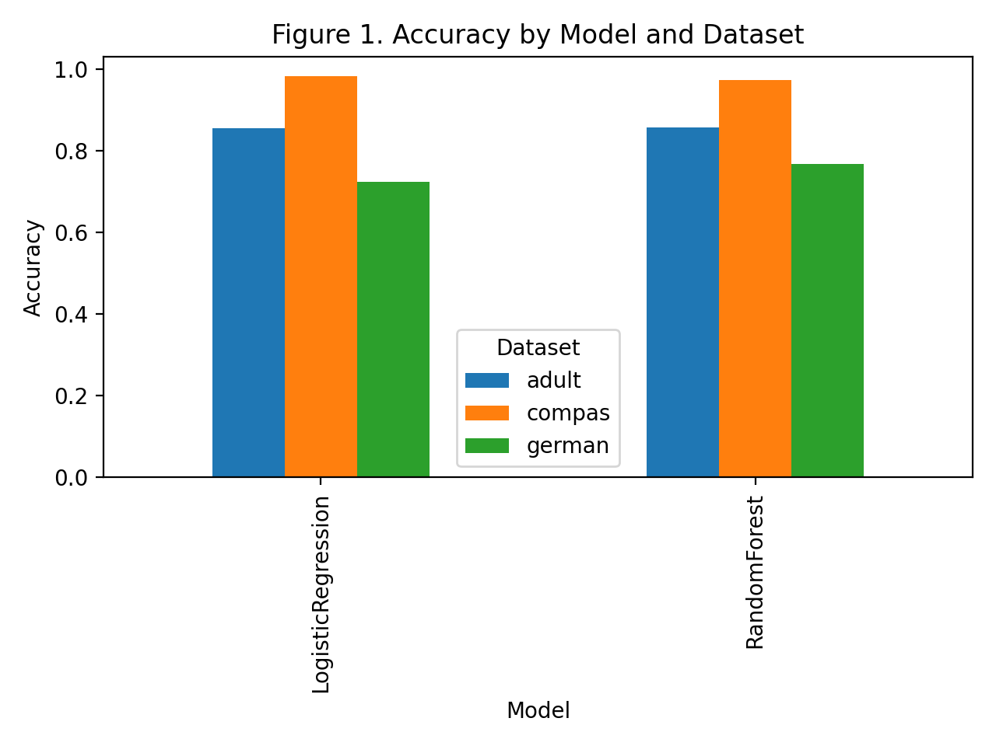
Figure 1. Accuracy by model and dataset. The Adult and COMPAS benchmarks are predicted at much higher accuracy than German Credit, while the gap between logistic regression and random forest is modest within each dataset.
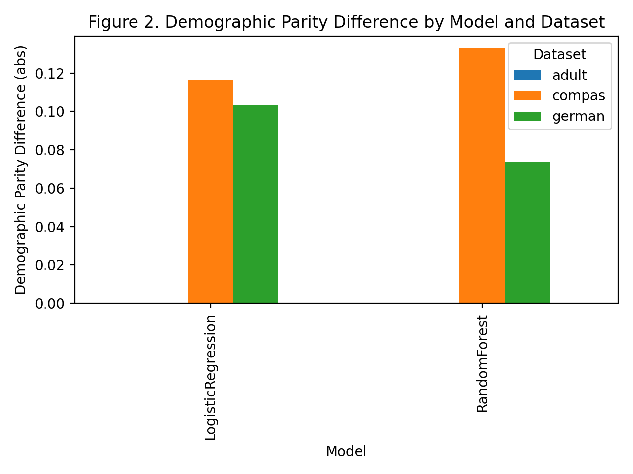
Figure 2. Demographic parity difference by model and dataset. COMPAS exhibits the clearest non-zero disparity in this metric, while Adult remains at zero under the current implementation and grouping choices.
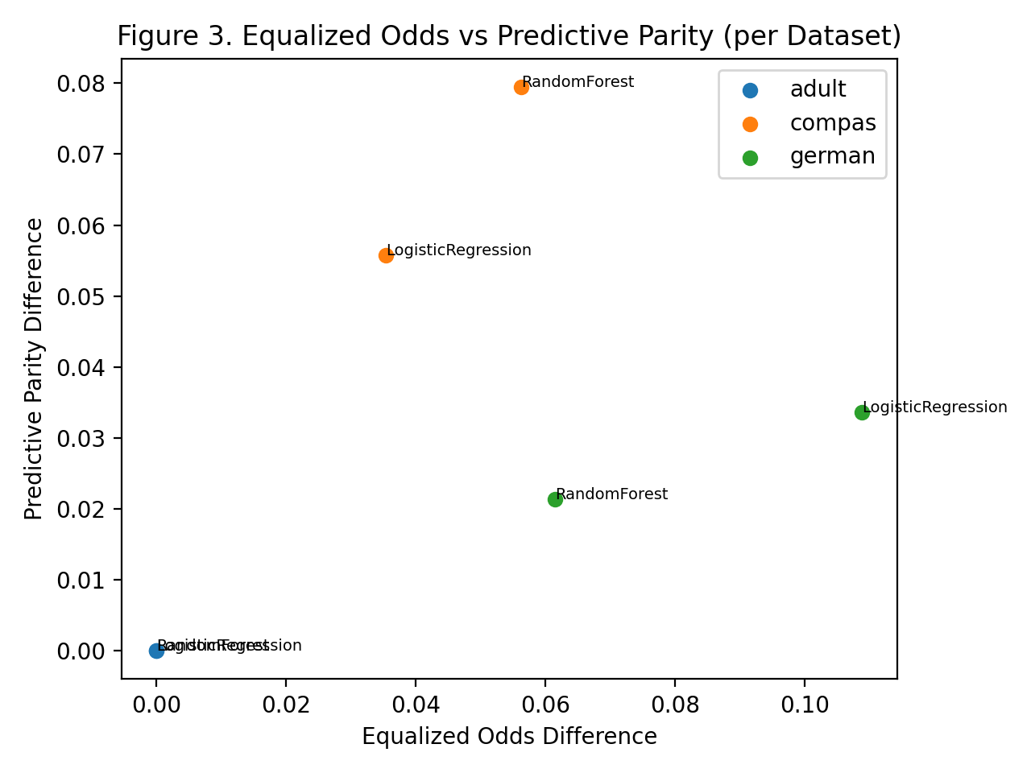
Figure 3. Equalized odds versus predictive parity. The scatterplot emphasizes that datasets with small predictive-parity gaps do not necessarily have small equalized-odds gaps, especially for German Credit.
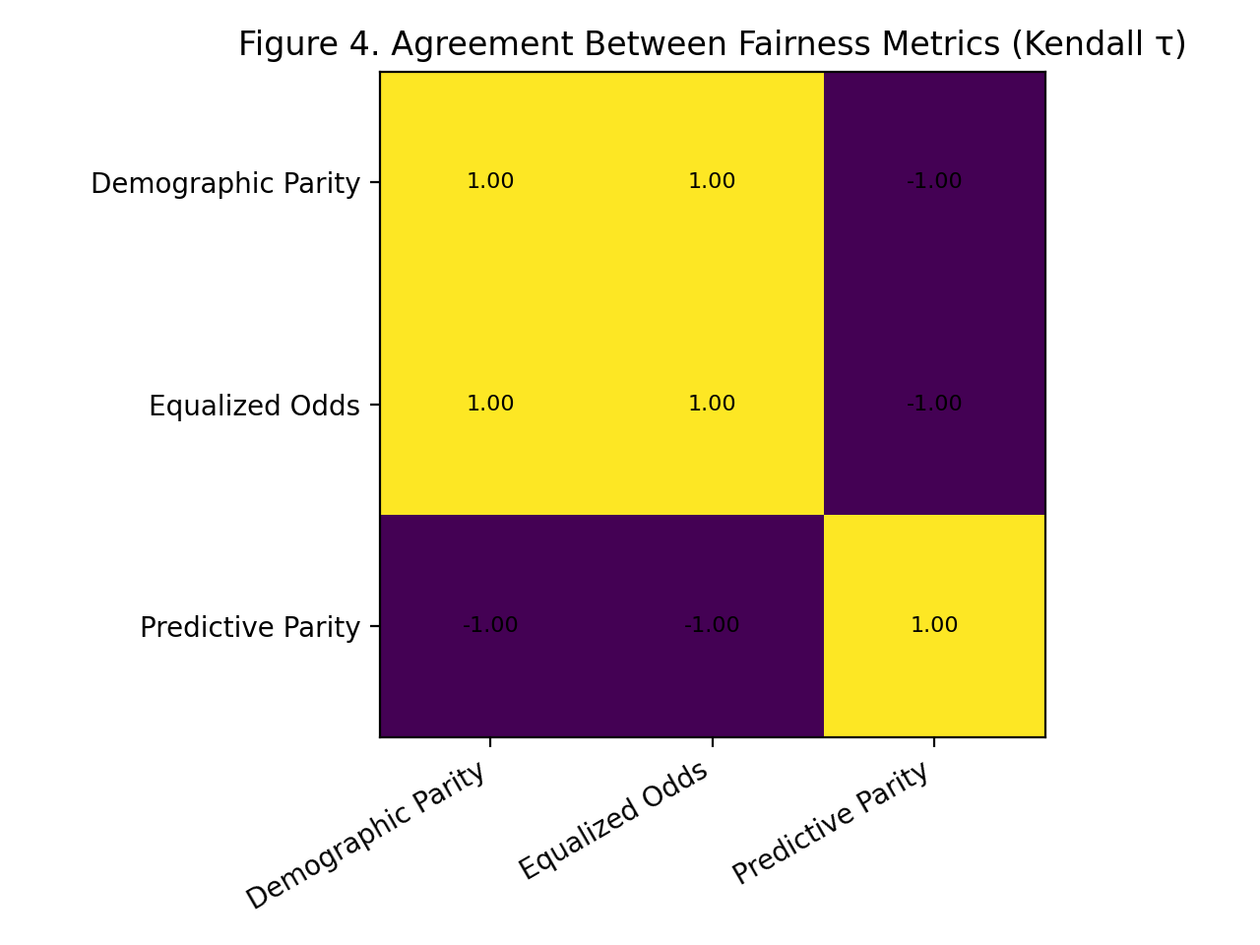
Figure 4. Kendall’s tau agreement heatmap. Demographic parity and equalized odds move together in the final aggregated model ranking, whereas predictive parity moves in the opposite direction.

7. Analysis & Discussion
The main contribution of the final implementation is interpretive rather than purely algorithmic. FairEval provides evidence that fairness auditing is unstable when framed as a single-metric exercise. The disagreement results matter because they change how one should read the table of model scores. A fairness benchmark is not simply a ranking device; it is an instrument for surfacing conflicting normative lenses. This distinction is especially important in educational settings, policy discussions, and deployment reviews where there is pressure to summarize complex model behavior in one clean sentence.
One lesson from the results is that dataset context matters at least as much as model family. The Adult benchmark yields effectively zero disparity for the implemented metrics and models. COMPAS, by contrast, yields small but clearly non-zero disparities across all three fairness metrics, while German Credit produces a mixed pattern where one metric remains low and another is much larger. A naïve evaluator might conclude that random forest is “more biased” because it performs worse on COMPAS. Another might conclude that random forest is “fairer” because it improves equalized odds on German Credit. Both statements are incomplete. The correct interpretation is conditional: fairness judgments depend on which harm notion is emphasized, which dataset is considered, and what tradeoff one is prepared to accept.
A second lesson is that agreement analysis turns a philosophical issue into a measurable artifact. The fairness literature has long argued that different criteria can conflict, but many practical toolkits still present long lists of metric values without explicitly quantifying how aligned those metrics are. By adding Kendall’s tau and Krippendorff’s alpha, FairEval makes the disagreement itself visible. This is more than a cosmetic improvement. In an actual model review workflow, disagreement statistics could be used as a trigger for deeper human analysis. A strong-consensus case might justify a short summary, whereas a weak-consensus or negative-consensus case should prompt more careful scrutiny, domain review, or stakeholder consultation.
The results also help clarify what the project is and is not claiming. It is not claiming that demographic parity or equalized odds is the “correct” fairness metric. It is not claiming that predictive parity is wrong because it disagrees. Nor is it claiming that logistic regression is categorically preferable to random forest. Instead, the benchmark demonstrates that multiple reasonable fairness summaries can yield different practical narratives. This interpretive modesty is important, especially because fairness research is vulnerable to overclaiming. A course project can still make a strong contribution by showing where certainty is unwarranted.
In that sense, the project responds directly to the instructor feedback from earlier milestones. One repeated concern in the feedback was that the work risked becoming a standard tabular fairness exercise unless it articulated a stronger empirical thesis. The final package addresses that concern by centering the question of metric agreement. Even though the implementation does not fully realize the most ambitious version of the cross-modal roadmap, it does produce a coherent and non-trivial analytic claim. The agreement matrix and negative alpha are not incidental outputs; they are the evidence for the project’s thesis.
The final package also improves substantially on earlier milestone weaknesses in terms of presentation and reproducibility. Earlier feedback noted limited references, incomplete tables and figures, and insufficient packaging. In response, the final deliverables now include explicit figures, a cleaned project structure, included datasets, regenerated outputs, an updated README, presentation materials, and recording scripts. This matters because fairness evaluation is not only about producing numbers; it is about communicating those numbers responsibly. A report that clearly states what was run, what the metrics mean, what the figures show, and what remains incomplete is more useful than a technically ambitious but opaque artifact.
Nevertheless, the current implementation should be read as a strong foundation rather than a definitive framework. The agreement findings are derived from only two model families and three tabular datasets. The sensitive attributes are coarse and mostly binary. The project does not include confidence intervals or resampling-based stability checks. The LLM evaluation path is architecturally present but not fully validated in the final results. These limitations prevent overgeneralization, but they do not erase the central insight. If anything, they strengthen it: even in a small, controlled benchmark, metric disagreement is already substantial. A larger cross-modal benchmark would likely reveal even more complexity.
The project also has practical implications for responsible AI workflows. Many organizations now ask model developers to provide fairness numbers as part of documentation or governance review. FairEval suggests that such requests should be reframed. Instead of asking, “What is the fairness score?” governance processes should ask, “Which fairness metrics were computed, what harms do they represent, and do they agree strongly enough to support the proposed conclusion?” This reframing is more honest and better aligned with the state of the literature. It also aligns with risk-based governance logic: disagreement among metrics is itself a signal of uncertainty that should inform decision-making.
Another implication concerns benchmark design. The project shows that even a relatively small metric set can produce conflict. Adding more metrics, more subgroup definitions, or more modalities will almost certainly increase complexity rather than simplify it. That does not mean broader benchmarking is undesirable. It means that benchmark frameworks must include interpretive tools, not just score generators. Agreement matrices, rank comparisons, and structured narrative reporting are therefore essential design features, not optional add-ons.
A final discussion point concerns the role of honesty in course-project evaluation. It would have been easy to overstate the optional LLM modules or present the roadmap as if every item had been fully implemented. The final package instead takes a more defensible approach: it delivers the strongest validated artifact available, documents the extension hooks, and states clearly where the implementation still falls short of the ideal design. That honesty makes the project stronger, not weaker. It shows that the student understands the difference between an architecture plan, a code scaffold, and a validated empirical result.
Taken together, the analysis and discussion support the following summary interpretation. FairEval’s final implementation demonstrates that fairness metrics can disagree sharply even in a small benchmark suite; that disagreement can be quantified; and reproducible packaging materially improves the usefulness of the evaluation. Those are meaningful outcomes for a Milestone 6 submission in the Benchmarking / Evaluation category.

8. Limitations & Threats to Validity
Several limitations and threats to validity should be stated clearly.
First, the empirical benchmark is still small. The validated results cover two models and three tabular datasets. This is enough to support a focused course-project claim about disagreement, but it is not enough to make broad statements about the full landscape of fairness metrics across all model classes, tasks, or domains. Additional models such as support-vector machines, gradient boosting, calibrated classifiers, and fairness-aware baselines would provide a richer comparison space.
Second, the current study uses coarse sensitive-attribute definitions. Adult is grouped by sex, COMPAS by race, and German Credit by personal-status-derived sex or similar fallback logic. These choices are practical and common in benchmark work, but they compress complex demographic realities into simplified categories. Such simplification can hide subgroup heterogeneity, intersectional effects, and context-specific harms. The reported fairness gaps should therefore be interpreted as benchmark-level indicators rather than exhaustive measurements of social inequity.
Third, the metric set is intentionally limited. Demographic parity, equalized odds, and predictive parity are important and illustrative, but they do not cover the entire fairness literature. Calibration difference, equal opportunity, subgroup robustness, individual fairness proxies, and counterfactual measures are omitted. The current agreement results therefore show disagreement within this selected metric subset, not across every plausible fairness criterion.
Fourth, the agreement analysis itself is based on a small ranking universe. With only two model families, Kendall’s tau values can become extreme and should not be overinterpreted as stable population parameters. The negative Krippendorff’s alpha is still informative, but it should be understood as a diagnostic signal from this particular benchmark configuration rather than a universal constant. Future versions should include more models, repeated data splits, and confidence intervals to assess stability.
Fifth, the project does not yet include statistical uncertainty estimates. No bootstrapped confidence intervals, permutation tests, or multiple-split replications are reported for the fairness metrics. As a result, the benchmark shows point estimates rather than uncertainty-aware intervals. This is acceptable for a baseline evaluation artifact, but stronger research claims would require additional statistical rigor.
Sixth, the optional LLM benchmarking path is not fully validated in the final package. Although the codebase includes adapters for CrowS-Pairs and BBQ, authenticated API execution was not bundled with the submission environment, and the stored output files reflect failed unauthenticated calls rather than valid model judgments. The architecture therefore supports cross-modal expansion, but the final report does not present the LLM branch as a completed experimental result. This is an important limitation because the original roadmap emphasized cross-modal coverage as a differentiator.
Seventh, the framework currently evaluates disparities but does not include mitigation interventions. It can identify patterns and disagreement among metrics, but it does not yet test reweighing, threshold adjustment, post-processing, or in-processing debiasing methods. From a practical standpoint, many users will want a benchmark not only to diagnose bias but also to compare mitigation options. That capability is a natural extension for future work.
Eighth, the project does not include a frontend dashboard in the final delivered artifact. The roadmap envisioned a richer reporting interface with regulatory-style audit summaries and potentially a Streamlit dashboard. The current package instead focuses on script-generated CSV and PNG outputs plus a written report and slide deck. This choice improved submission reliability and coherence, but it means the artifact is stronger as a reproducible research package than as an interactive end-user product.
Ninth, fairness benchmarks themselves have validity limits. Datasets such as CrowS-Pairs and even COMPAS carry known methodological controversies. The project acknowledges these issues but does not solve them. FairEval should therefore be seen as a framework for transparent benchmarking, not as a definitive arbiter of ethical acceptability.
Finally, there is the general threat of scope compression. The project began with an ambitious roadmap spanning tabular ML, LLM benchmarks, LLM-as-a-judge, regulatory-ready reporting, and broader coverage. The final implementation prioritizes a coherent core over superficial completion of every item. This was the right decision for Milestone 6, but it means that some roadmap goals remain future work. The report treats that tradeoff honestly so the final artifact can be judged on what it actually delivers.

9. Conclusion & Future Work
This report presented FairEval, a reproducible benchmarking framework for studying whether fairness metrics agree when auditing machine-learning systems. The final implementation evaluates logistic regression and random forest on Adult, COMPAS, and German Credit; computes demographic parity, equalized odds, and predictive parity; and quantifies inter-metric agreement using Kendall’s tau and Krippendorff’s alpha. The main empirical result is that fairness metrics do not behave as interchangeable summaries. In the final benchmark, demographic parity and equalized odds agree strongly with each other, while predictive parity systematically disagrees, yielding a negative overall alpha. That finding directly supports the project’s central thesis: fairness evaluation should be treated as a multi-metric diagnostic process rather than a single-score decision rule.
The final package also demonstrates the practical value of reproducible benchmarking. Datasets, outputs, figures, code, scripts, README documentation, and presentation materials have all been organized into a coherent Milestone 6 submission. This packaging matters because fairness claims must be inspectable if they are to support responsible decision-making.
Future work should expand the metric set, add more model classes and repeated-split statistics, complete the LLM evaluation branch with authenticated benchmark execution, and implement the originally envisioned LLM-as-a-Fairness-Judge module. A dashboard layer and mitigation experiments would further strengthen the framework. Even in its current form, however, FairEval makes a useful contribution: it shows that disagreement among fairness metrics is not a philosophical footnote but an empirical property that benchmark tools should measure and report explicitly.

References
Barocas, S., Hardt, M., & Narayanan, A. (2019). Fairness and Machine Learning. fairmlbook.org.
Bellamy, R. K. E., et al. (2019). AI Fairness 360: An extensible toolkit for detecting, understanding, and mitigating unwanted algorithmic bias. IBM Journal of Research and Development, 63(4/5), 4:1-4:15.
Bird, S., et al. (2020). Fairlearn: A toolkit for assessing and improving fairness in AI. Microsoft Research technical report.
Bommasani, R., et al. (2021). On the opportunities and risks of foundation models. arXiv preprint arXiv:2108.07258.
Chouldechova, A. (2017). Fair prediction with disparate impact: A study of bias in recidivism prediction instruments. Big Data, 5(2), 153-163.
Dixon, L., et al. (2018). Measuring and mitigating unintended bias in text classification. Proceedings of the AAAI/ACM Conference on AI, Ethics, and Society.
Gallegos, I. O., et al. (2024). Bias and fairness in large language models: A survey. Computational Linguistics, 50(3), 1097-1179.
Hardt, M., Price, E., & Srebro, N. (2016). Equality of opportunity in supervised learning. Advances in Neural Information Processing Systems, 29.
Kleinberg, J., Mullainathan, S., & Raghavan, M. (2017). Inherent trade-offs in the fair determination of risk scores. Proceedings of Innovations in Theoretical Computer Science.
Liang, P., et al. (2022). Holistic evaluation of language models. Transactions on Machine Learning Research.
Mehrabi, N., et al. (2021). A survey on bias and fairness in machine learning. ACM Computing Surveys, 54(6), 1-35.
Nangia, N., Vania, C., Bhalerao, R., & Bowman, S. R. (2020). CrowS-Pairs: A challenge dataset for measuring social biases in masked language models. Proceedings of EMNLP.
Parrish, A., et al. (2022). BBQ: A hand-built bias benchmark for question answering. Findings of the Association for Computational Linguistics: ACL 2022.
Pedreshi, D., Ruggieri, S., & Turini, F. (2008). Discrimination-aware data mining. Proceedings of the 14th ACM SIGKDD International Conference on Knowledge Discovery and Data Mining.
Pleiss, G., Raghavan, M., Wu, F., Kleinberg, J., & Weinberger, K. Q. (2017). On fairness and calibration. Advances in Neural Information Processing Systems, 30.
Raji, I. D., et al. (2020). Closing the AI accountability gap: Defining an end-to-end framework for internal algorithmic auditing. Proceedings of the Conference on Fairness, Accountability, and Transparency.
Suresh, H., & Guttag, J. (2021). A framework for understanding unintended consequences of machine learning. arXiv preprint arXiv:1901.10002.
Ustun, B., & Rudin, C. (2019). Learning optimized risk scores. Journal of Machine Learning Research, 20(150), 1-75.
Zliobaite, I. (2017). Measuring discrimination in algorithmic decision making. Data Mining and Knowledge Discovery, 31, 1060-1089.

